DATE : 23-02-26
EXPERIMENT - 1
Create a simple cloud software application and provide it as a service using any Cloud Service Provider to demonstrate Software as a Service (SaaS).
AIM: The aim is to develop a simple, cloud-based application and demonstrate the principles of SaaS by providing access to the software via the cloud, making it scalable, cost-effective, and easily accessible for users.
PROCEDURE:
Step1:Go To Zohocreator.Com and Login to Your Account
Step2:Click Create New Application and Create from Scratch
Step3: Enter Application Name and Create Application
Step4:Click On Create New Form and Name the Form
Step5:Enter The Details
Step6:The Software Has Been Created.

Step1:Go To Zohocreator.Com and Login to Your Account
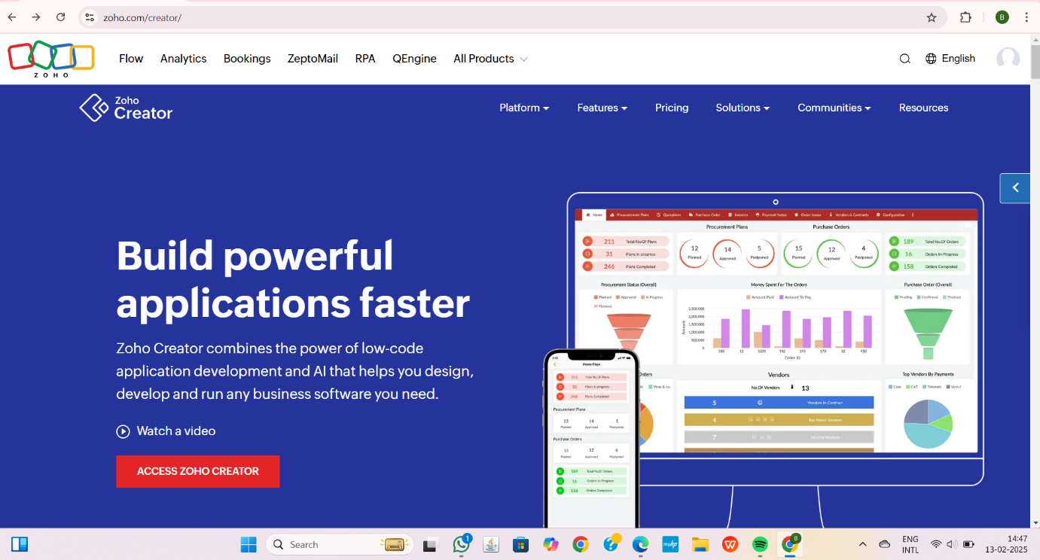
Step 2:Click Create New Application and Create from Scratch
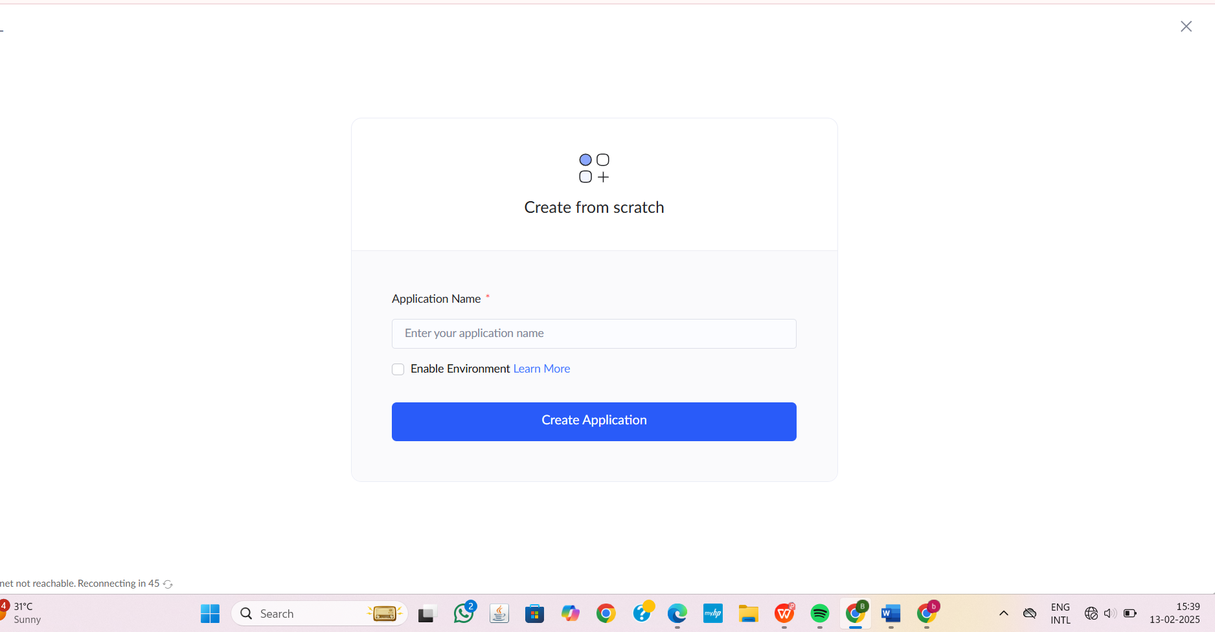
Step 3: Enter Application Name and Create Application
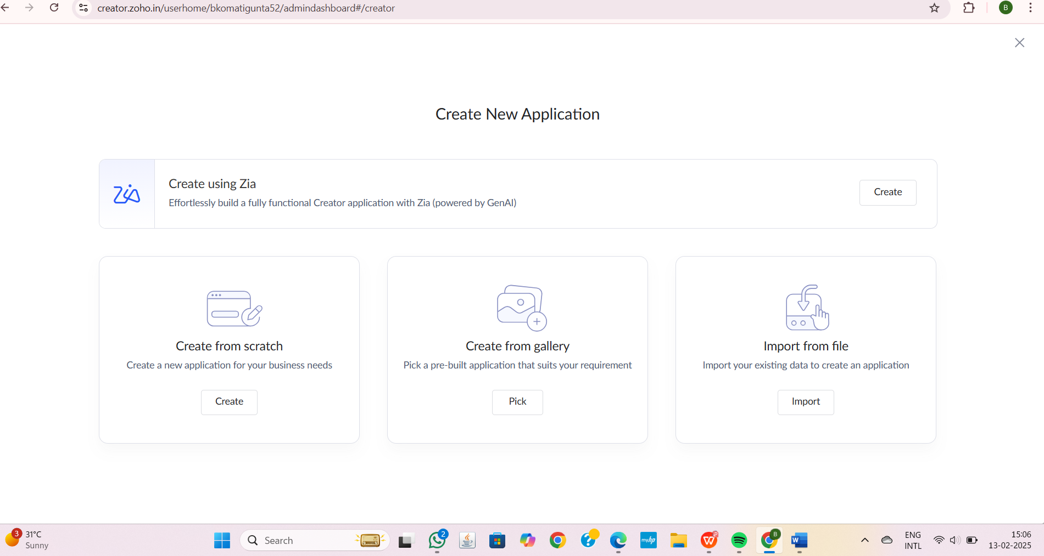

Step4:Click On Create New Form And Name The Form

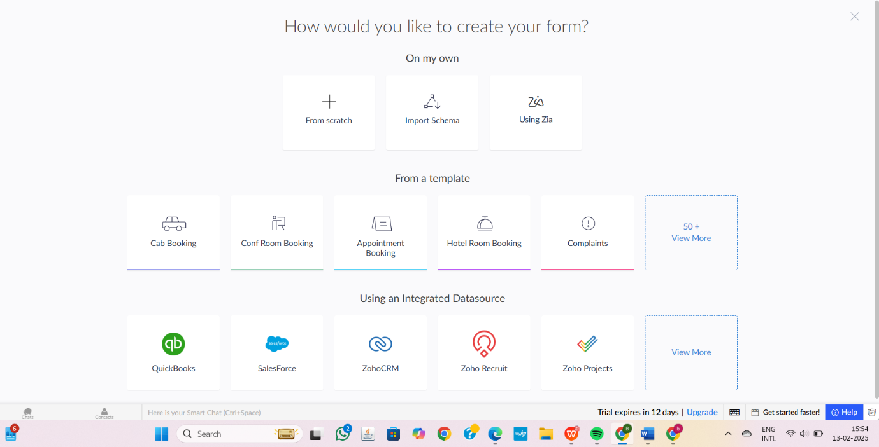

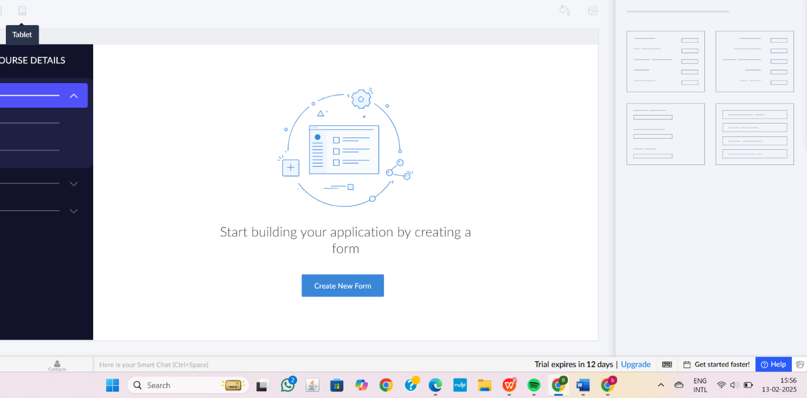

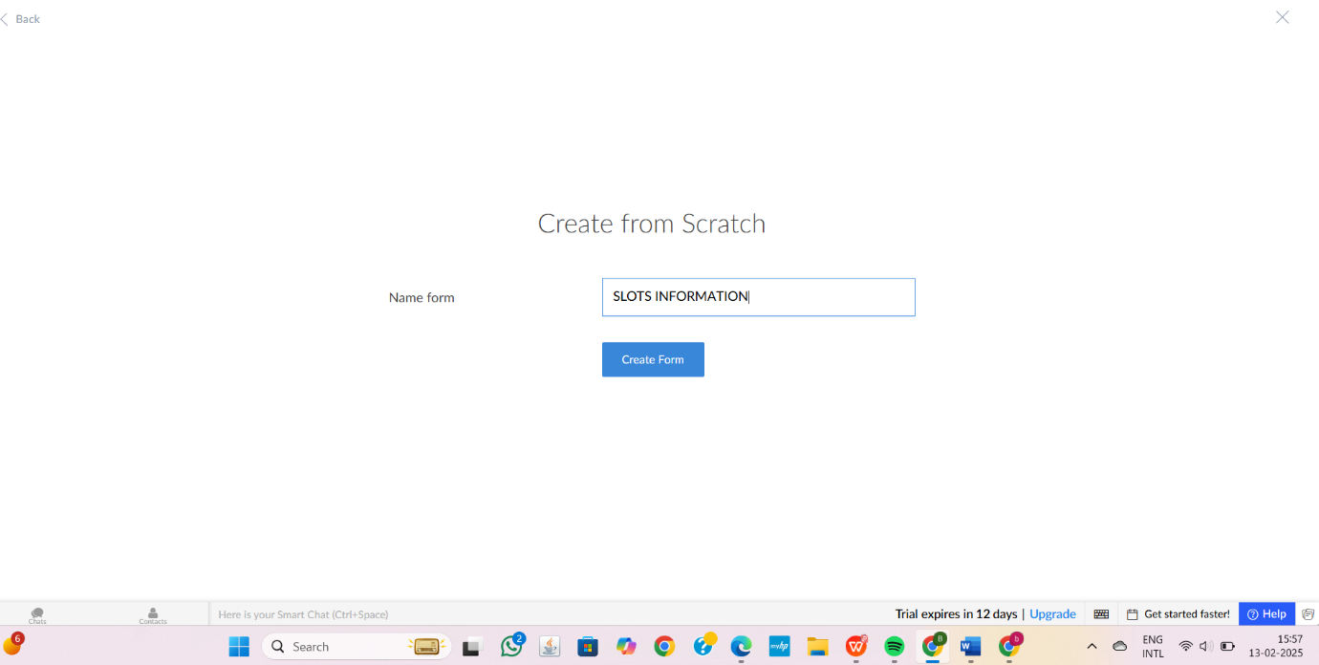

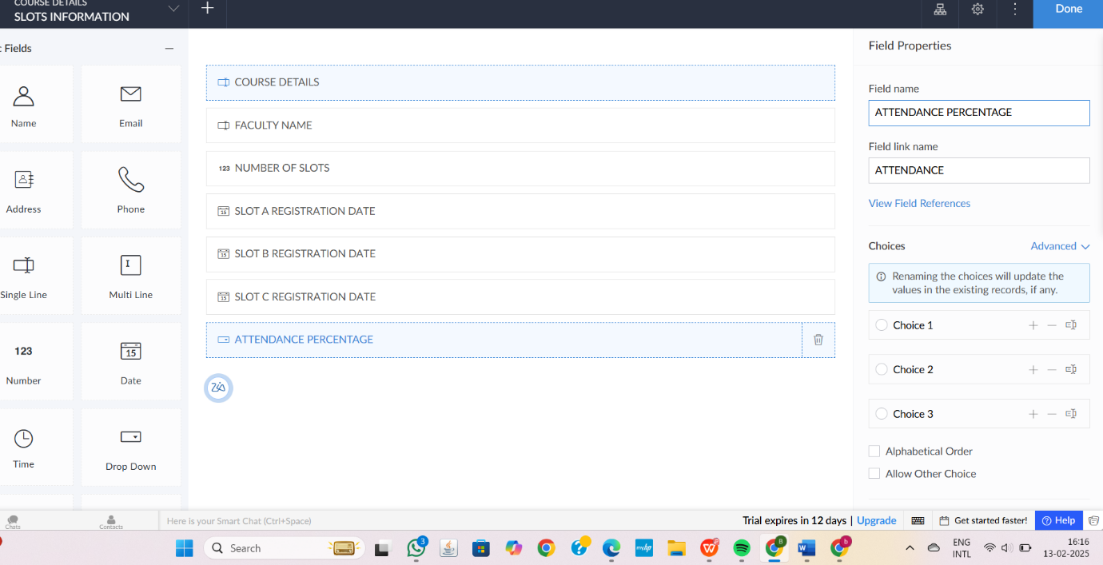

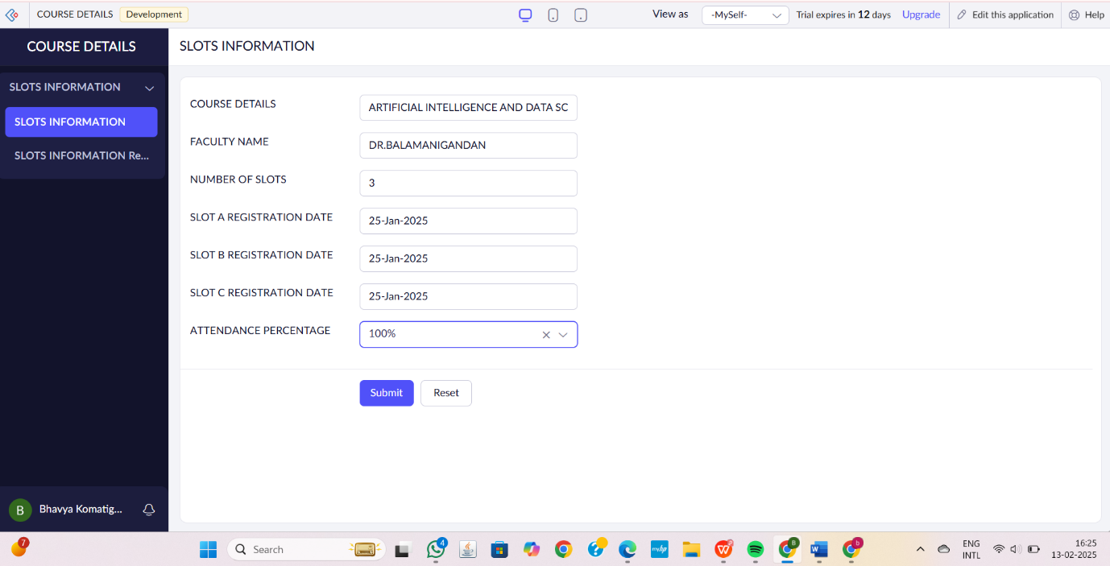
2.Faculty Information and Its Details
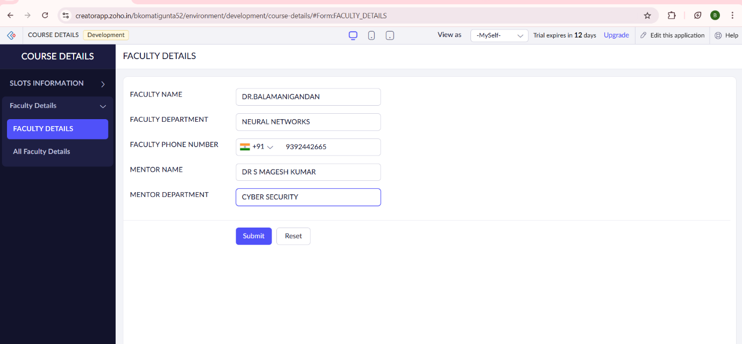

3.Slot Details
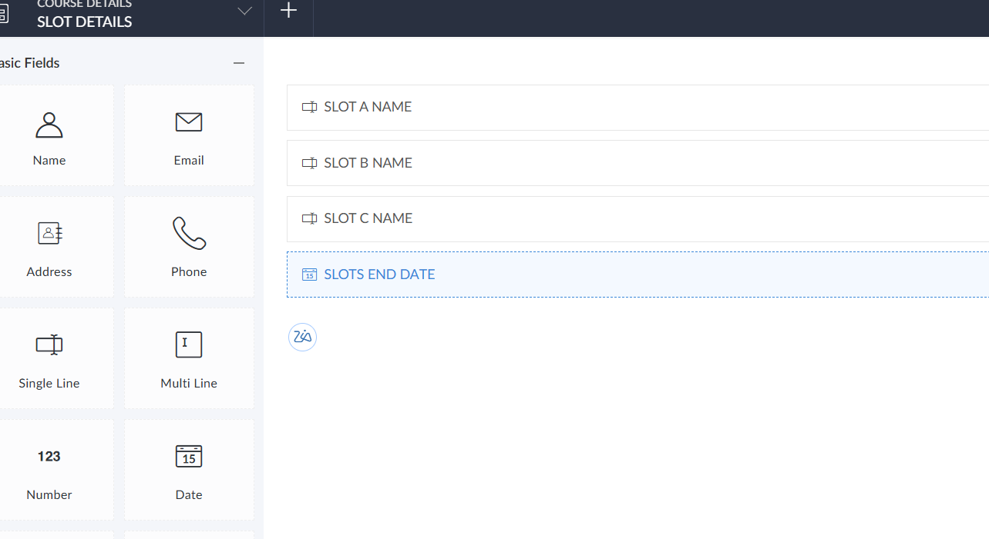

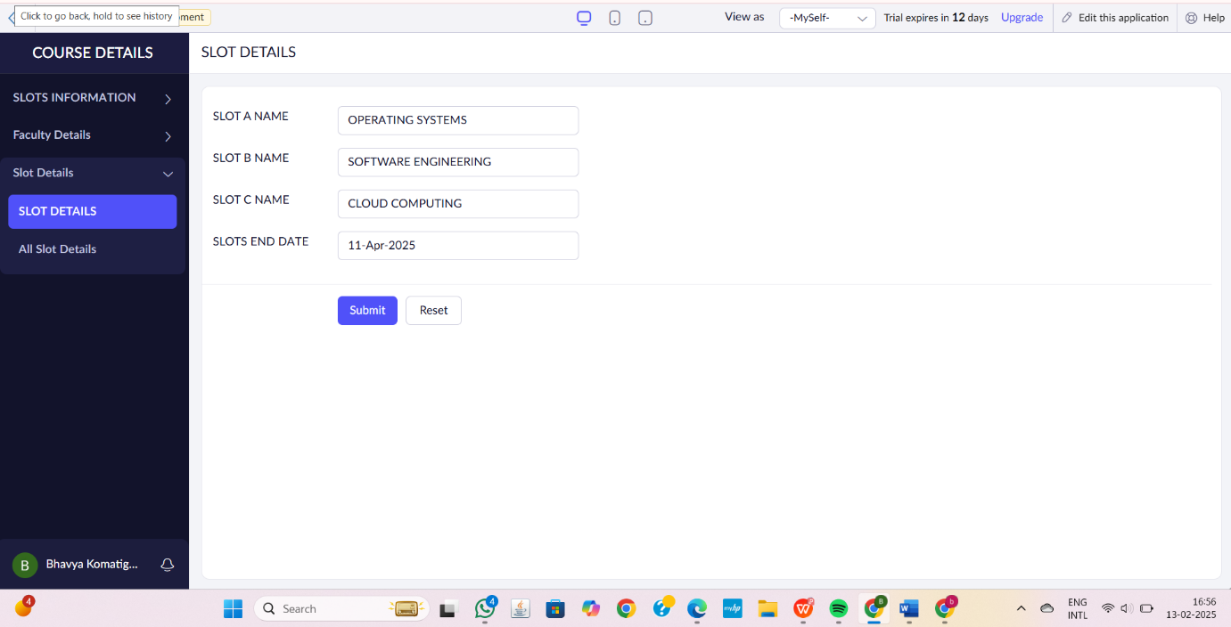
Step6:The Software Has Been Created.

